# 

# PROJECT REPORT on Birds Adventure Application

# 313- MAD (Team 2)

**SUBMITTED BY SUBMITTED TO**

Arshpreet Singh(1896249) Prof. Gilles-Phillippe Gregoire

Ujjal Singh Pawra(1895419) Prof. Sakkaravarthi Ramanthan

Pritpal kaur Dhindsa (1895494) Prof. Sakshi Sharma

Sandeep Kumar (1896182) Prof. Harshkumar Dave

Prabhjot Kaur Dhaliwal (1896506) Prof. Silviya Paskaleva

Naga Nalla (1896353) Prof. Pargol Poshtareh

BIRDS ADVENTURE APP

# C:\Users\naga\AppData\Local\Microsoft\Windows\INetCache\Content.Word\bird.gif

**Table of Contents**

1. Aim 2
2. Scope 2
3. Specific Requirements 2
   1. Functional Requirements 4
   2. Non-Functional Requirements 8
4. Use Case Diagram 9
5. Use Case Scenarios 10

1. Class Diagram 25
2. ER Diagram 26
3. Conceptual Data Model 27
4. Document Data Model 28
5. Firebase Collection Database 29
6. Screens 31

**INTRODUCTION**

The era of mobile technology opens the window to the android app, these apps are taking over the websites eventually. This is the time for building the applications for each aspect and for easy accessibility to users. This app "Birds Adventure App" will be a handy application and keep track of the species we see in the field, their habitat, and irrespective of the internet. This way the users will have the best knowledge on birds, the music of the birds, pictures, videos, and the location of where the birds are located. It is easy to use a birding app, where a user can have his own personal space to upload the new information on birds, and can explore the plethora of birds and bird’s information. Sometimes, it's tricky to identify the name of the flying bird. For example, Falcons, Eagles, Raptors are much alike and difficult to recognize, in this case, we can search for a name and get the results for the specific bird and compare it with the bird we see and get the information of the bird within the app. In addition, if the feature "Features Bird" is turned on, the app sends the notification to users whenever the users pass through the locations (specified in the app with regional birds) and can be turned off. However, irrespective of the feature, Users will still get the notifications if the user marked the listing bird to his favorites.

1. **Aim**

Developing an interest in birds quickly reveals just how intimately connected we are with earth’s other inhabitants. All living creatures are interdependent, but humans need birds in the world much more than they need us. So, we came up with an idea of creating a Birds Adventure App that will target the audience who are more interested in collecting media about birds and can view any bird’s info from the app. The Birds Adventure App. is a nature application that allows users to share their media with others so that more and more people connect with nature. At the end, the main objective behind this application is to help people generate their interest in birds in order to ensure a healthy ecosystem

1. **Scope**

We believe our Birds are nature’s one of the most beautiful creatures. Birds adventure application is an interesting place where a guest user can see some featured bird’s pictures, videos and listen to their sounds. It is a great hub for registered users as there are many interesting functionalities in the application such as a user can create his own personal collection which can be images, video clips and sound clips. User has a choice to create the folder of his own choice to organize the captured stuff. Application users can retrieve information about specific birds as they can search on the search page by the name or location of a bird. He can add birds into his favourite list to get the notification about their regions. Users will receive notifications regarding featured bird’s specific locations.

1. **Specific Requirements**

* Before Registration user will be able to click on a Sign up and a Login button .
* New users will register in the app by providing basic personal information to create their profile.
* After registering/login, the user will view a **Home** page, where the user can view 5 sections including Homepage –The First is the **Homepage** section, where user will able to see some featured birds list and overview of the app. The Second is the **Search** section, where there user will able to page, users can search birds by filters (name, location/region).The Third is the **Upload** section, where there is an Upload media button, highlighted for the user, to demonstrate that this is one of the main features of the app. The Fourth is the **Notification** section, where In the **Notifications** page, a list of notifications is displayed. The Fifth is **My Library** (folder structure), where the user can view the info/summary of contents My Library, and a button to go to My Library.
* Users can view the **Menu** which they can open by clicking on 3 dots on the top right corner of the screen. In the Menu, users can view 6 options – My Profile, Featured Birds, News, News, Settings, and Logout.
* In the **Toolbar** on the Home page, there are 5 options: Home, Search, Upload, My Library (folder structure),Notifications.
* In the **Search** page, users can search birds by filters (name, location/region). The search results are displayed via a vertical-view list containing the image and name of the bird. By clicking on any bird in this list, the user can view the Bird’s profile page.
* In the **Bird’s profile** page, users can view 3 tabs. The first tab is **Description** – users can view the enlarged image of the bird and relevant description of the bird including name, biome, habitat, location/region, general description. Additionally, a user can add the bird to his favorites collection by clicking on Favorites icon. The second tab is **Media** – users can view 3 options namely Images, Videos, Sound clips. In each of these options’ users can view the relevant media content. The last tab is **Location Map** – users can view the live map of the location and the target location will be highlighted/pin-pointed.
* In the **Upload** page, users can click images, record videos or sound clips. This media will be uploaded in the My Library page.
* In the **My Library** page, users can organize their uploaded media in a folder structure. This page contains 3 sections namely Images, Videos, and Sound clips. In each section there is a **Default** folder, in which all the uploaded media is stored by default, when you click/record it. However, users have the option to move any media content to a different folder with any name, or make new folders inside any folder to store media content. Moreover, users can view or delete any uploaded media content, and even rename or delete any folder. While viewing the media content, users can share the media URL on social platforms like Facebook, WhatsApp, etc.
* In the **Favorites** page, the user can view the vertical-view list of the birds he added to his Favorites collection. By clicking on any bird in this list, the user can view the Bird’s profile page, just as in the Search page.
* In the **Featured Birds** page, users can view the vertical-view list of the birds which are in the Featured Birds collection. By clicking on any bird in this list, the user can view the Bird’s profile page, just as in the Search page.
* In the **News** page, users can view the latest news related to birds.
* In the Settings page, the user can turn ON/OFF the option to receive a notification if he is in close proximity to the location of featured birds or Favorite birds. Users can even set the proximity radius from their location to the location of a featured/Favorites bird.
* User will receive a **notification** if he is in close proximity to the location of any of his Favorites bird collection or Featured birds, provided he has set it to ON this in the Settings page. He can also set the proximity radius in Settings. When the user clicks on the notification, the Notifications page will be opened.
* In the **Notifications** page, a list of notifications is displayed.When the user clicks on any item in the list, then the **Birds list** will be displayed (just like in the Search page) containing those birds which are in close proximity to that specific region.
* In the **View Profile** page, a user can view or edit his profile which contains his personal information which he provided on registration. Additionally, users can also change their login password.
* The app will ask the user for various **Permissions** like – location, microphone, and camera, in order to effectively use the app.

**3.1Functional Requirements**

|  |  |  |  |
| --- | --- | --- | --- |
| **Requirement ID** | **Requirement** | **MUST/COULD/**  **SHOULD/WOULD** | **Comments** |
| FR01 | Birds adventure application will allow the user(Guest user) to view the basic  content regarding some featured birds that will include a brief description, a picture, a video and a sound clip before registration to the application . | Would | System will display  the basic information that a user can see before registration and a user can have a basic idea of what the application is. |
| FR02 | Birds adventure  application must have a sign-up screen, where the user must have to enter his/her information such as   username, email, password, etc. | Must | System will check the username in the database if it doesn’t exist then the information entered by the user will be saved to the database when he will click on the signup button and a new account will be created for the user otherwise if the username exists then it will show a message that this user already registered . |
| FR03 | The Birds adventure application must have a Sign In screen where the user will enter his username and his password. | Must | The system will check the credentials username and password with the database, if a user is a valid user then it will direct him to the home page else it will show a message that this user doesn’t exist. |
| FR04 | After Signup/Sign In the user must be directed to the home page. | Must | When the user Sign In or Signup the homepage should be the next page to display. |
| FR05 | The Home page must contain sections such as Camera to capture, my library (user’s personal collection folders) and featured birds. A news section that will lead to the birds related news. | Must | On the homepage the system will display the main functions of the application such as camera, library etc. |
| FR06 | On the homepage a bottom app bar must contain sections such as home, search ,upload ,my library and favourites. | Must | The system shall lead to most of the sections of the application from the homepage so that it is easy to access to the users . |
| FR07 | The application must have a page where the user can see the list of the birds and a search bar will be there where he can search by the bird’s name or location of the bird’s sites. | Must | The system shall filter all the  bird names and the locations of the bird sites, according to the name or location entered by the user. |
| FR08 | On the bird’s list page, a bird’s picture will be there with the bird's name and its site’s location and this list will be a vertical list in an alphabetical order. | Would | The system will fetch a bird’s list and will display the  list of birds with  the pictures ,names and locations of the birds. |
| FR09 | On the bird’s list page ,on the right-hand side  of each bird’s name a favourites button must be there so that a user can directly add a particular  bird to his favourites. | Should | The system shall save that specific bird’s name to the database as the user's favourites. |
| FR10 | Application will have a bird’s profile page where a user can view three tabs description, media and location. In description a picture of the bird, it’s size, diet, location, colour, habitats and description of a particular bird can be found, On the other side in media tab a user can find media content like bird’s pictures, can watch its videos and listen to the bird’s sounds. Location tab will lead to a map view with a pin pointing to the bird’s location. | Must | The system should fetch the details and should show the bird’s details in the description tab and media will be included in the media tab and a google map view should be opened when the location tab is opened. |
| FR11 | On the bird’s profile page there must be a favourites button to add the bird to the user's favourites list. | Should | The system shall update the favourite details of the user  in the database. |
| FR12 | Application will have a My Collection page (user’s library) which will include the user's personal collection like pictures, videos and sounds. On the collection page user can organize their captured media in a folder structure. This page contains three main sections namely Pictures/images, Videos and sound clips. In each section the data will be stored in the default folders but user will have a facility to organize his data in various folders and he can give names to these folders of his own choice. | Must | The system will save the user's collection such as captured pictured videos and recorded sounds into his personal library in respective folders. |
| FR13 | The Application will have a favourites page where user’s favourites will be listed in a vertical list and by clicking on any bird in this list user will be directed to that particular bird’s profile page and a delete button will be on the right hand side to delete a bird  from this list. | Must | The system will display user’s saved favourites and the user should be allowed to jump into a selected bird’s profile page. Favourites details of the user  should be updated in the database. |
| FR14 | Application will have a user profile with his personal information. | Must | The system shall use the database to retrieve information about the  user and should display it  on the profile page. |
| FR15 | The user must be able to edit or  update   his profile details | Must | The system shall update the database to update information about profile details. |
| FR16 | The user shall be able to change his profile picture. | Would | The system shall update the database to modify the user’s profile information. |
| FR17 | Application must have a camera and a microphone feature. The user can capture pictures and videos of the birds and he can also record the bird’s sounds. | Must | The system will allow the  user to use a camera and sound recorder to capture a picture or a video and to record the sounds of the birds. |
| FR18 | Application must ask user permissions for the camera and microphone access. | Must | The system  must ask the user to set permissions to access the camera and microphone. |
| FR19 | The Application must ask the  user permission for location access. | Must | The system  must ask the user to set permissions to access location services. |
| FR20 | On the settings/preferences page, the user can turn on/off the option to receive a notification if he is in close proximity to the site’s location of a featured bird. User can even set the proximity radius from his location of a featured bird. | Should | The system shall use the online cloud/database notifications service. |
| FR21 | The Application will have a side menu with options like profile, featured birds, news ,notifications, settings and sign out. | Would | The system will direct the user to the respective pages from these side menu items. |
| FR22 | The user shall be able to view the locations of the sites on the map. | Must | The system shall open the maps. |
| FR23 | On the news page , a user can read news on birds and get to know about the current events related to birds. | could | System will fetch the latest news about the birds and will display these on the news section. |
| FR24 | The Notification page must contain various notifications received by the user like about his favourite birds and featured birds with notification description on the left side and timestamp of the received notification on the right side. Each notification will lead the user to a page containing a list of those birds which are in close proximity to that specific region. | Must | The system shall use the online cloud/database notifications service. |
| FR25 | The user shall receive a notification if he is in close proximity to the location of any of his favourite/featured bird’s collections. He can set the proximity radius in settings. | Should | The system shall use the online cloud/database notifications service. |
| FR26 | Users can share the media(captured images, videos and sound clips ) URL with their family or friends on social platforms like Facebook, WhatsApp, etc. | Must | The system shall use the social network integration login to your app and share their actions |
| FR27 | The User must have the option of Log out/sign out. | Must | The system shall log out the user from the application. |

* 1. **Non-Functional Requirements**

|  |  |  |  |
| --- | --- | --- | --- |
| **Requirement ID** | **Requirement Statement** | **MUST/COULD/**  **SHOULD/WOULD** | **Comments** |
| NFR1- | The platform must be Android and minimum version should be  Android 5.0 and above. | SHOULD | Required version must be there. |
| NFR2- | The maximum number of users using the app at one time could be Between 900 to 1000. | COULD | Max users can be 1000. |
| NFR3- | The Application will never disclose any personal information of any users. Even in the Search option the user personal Library of birds which include media (pictures, video and sound clips) are not visible to any other user while he/she is searching | MUST | Data is always secured in this application. |
| NFR4- | The Application will be available at all the time on the user’s android device as long as the device is in proper working order. | MUST | Internet connection is a must. |
| NFR5- | In case the system is crashed, the recovery system should provide the last stable version. | MUST | Back-up is a must. |
| NFR6- | The Application can be maintained easily by the admin. The admin can add more features in future | COULD | Future scope. |
| NFR7- | The user data must be saved for period of five months | MUST | Minimum record keeping time is 6 months. |
| NFR8- | There will be no incorrect or out-dated information delivered to the user   at any cost. | MUST | Provide correct and valid information to users regarding birds. |
| NFR9- | The Application will provide the real time information of the birds. Users will also get notification as he/she enters a new region automatically. The application will provide up to date information regarding birds. | MUST | Get notification according to the new region. |

1. **Use Case Diagram**

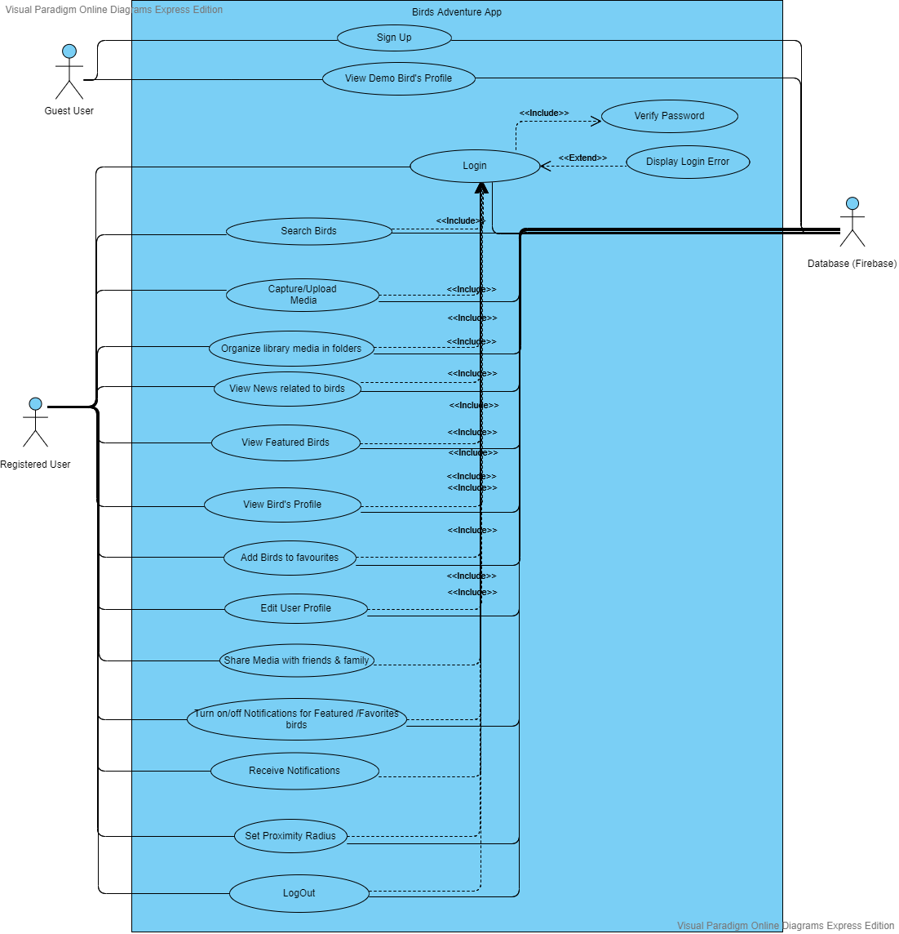

1. **Use Case Scenarios**
   1. **USE CASE DIAGRAM**

This use case diagram defines the interactions between the users of the app. The main actors of the Soccer app in this use case diagram are- guest user, registered user (team manager and league manager) who perform the different roles such as updating information of the players, teams, matches, leagues, scores, update profile etc. The different symbols used in this diagram are explained below.

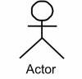

Actor specifies a role played by a user or any other system that interacts with the subject.



It defines an interaction between an actor and a system to Achieve a goal.

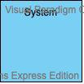

This box indicates the boundary of the system you want to highlight or focus on.

Use Case Model for Birds Adventure Application is represented at different levels of abstraction using UML use case diagram.

|  |  |
| --- | --- |
| **List of use cases** | |
| UC1 - Sign Up new user | UC10 – Edit user Profile |
| UC2 - Login | UC11 - Share media |
| UC3 – Capture Media | UC12 - Organize Library Folder |
| UC4 – Upload Media | UC13 - Turn on /off Notifications |
| UC5 – Search Birds | UC14 - Proximity Radius |
| UC6 – View News | UC15 - Logout |
| UC7 - view Featured Bird |  |
| UC8 – View Bird's Profile |  |
| UC9 – Add Birds to Favourites |  |

List of use cases

**UC-1: Sign Up**

|  |  |
| --- | --- |
| System: | Birds Adventures Application |
| Identifier: | UC-1 |
| Author(s): | Team 2 |
| Version: | None |
| Name: | Sign Up new User |
| Pre- Condition(s): | The user is non-registered and does not have an account on Bird Adventures Application |
| Post- Condition(s): | The user is directed to the Home Page of the Application. |
| Trigger: | The user has clicked on the Sign-Up button. |
| Normal Flow: | * User clicks on Sign Up button to create the user profile. * User enters the details in the form and sets up the user name and password. * Then after registration user will be redirected to the Home Page . |
| Alternate Flow: | None |
| Exceptional Flow(s): | **Exception:** There is an occurrence of internet connection failure.  1. The system will prompt the message “No Internet Connection, try Again” on the phone Screen. |
| Related Actor(s): | **Primary**-Non-Registered User  **Secondary**-None |
| Related Use Case(s): | None |

UC-1: Sign Up New User

**UC-2: Login**

|  |  |
| --- | --- |
| System: | Birds Adventures Application |
| Identifier: | UC-2 |
| Author(s): | Team 2 |
| Version: | None |
| Name: | Login |
| Pre- Condition(s): | The user is registered and has an account on Bird Adventure Application |
| Post- Condition(s): | The user is directed to the homepage of Application Which is specific to the user. |
| Trigger: | The user has clicked on the Login button. |
| Normal Flow: | * User clicks on the Login button. * User enters the user name and the password in the form. * User is directed to the homepage specific to the user. |
| Alternate Flow: | * User clicks on “forget password”. * User enters the email used for registration. * Email to change password is send to the given email address. * User changes the password and confirms the changes. * User is directed to the Login page. * User enters the user name and the password in the form. * User is directed to the homepage specific to the user. |
| Exceptional Flow(s): | **Exception:** The user enters wrong password or username.  2. The system will prompt the message “Wrong User name or password, Try again” on the phone screen. |
| Related Actor(s): | **Primary**-Registered User  **Secondary**-None |
| Related Use Case(s): | None |

UC-2: Login

**UC-3 – Capture Media**

|  |  |
| --- | --- |
| System: | Birds Adventures Application |
| Identifier: | UC-3 |
| Author(s): | Team 2 |
| Version: | None |
| Name: | Create Media |
| Pre- Condition(s): | * The user is registered and must have an account on Birds Adventure Application. * User Logs in with correct username and password * User will give permissions to phone camera and audio. |
| Post- Condition(s): | The user is directed to Home Page where he/she will create media. |
| Trigger: | The user has clicked Camera Icon and camera will open to captures videos and photos of birds. |
| Normal Flow: | * User click on Camera icon to capture media. |
| Alternate Flow: | None |
| Exceptional Flow(s): | None |
| Related Actor(s): | **Primary**-Registered User |
| Related Use Case(s): | None |

UC-3: Capture Media

**UC-4: Upload Media**

|  |  |
| --- | --- |
| System: | Birds Adventures Application |
| Identifier: | UC-4 |
| Author(s): | Team 2 |
| Version: | None |
| Name: | Upload Media(pictures and videos) |
| Pre- Condition(s): | * The user is registered and must have an account on Birds Adventure Application. * User will give permissions to phone camera and audio. |
| Post- Condition(s): | User can Upload on Media on application. |
| Trigger: | user Select the media from phone's library. |
| Normal Flow: | * User selects the media file from the stored files. |
| Alternate Flow: | None |
| Exceptional Flow(s): | **None**. |
| Related Actor(s): | **Primary**-Registered User |
| Related Use Case(s): | None |

UC-4: Upload Media

**UC-5: Search Options**

|  |  |
| --- | --- |
| System: | Birds Adventures Application |
| Identifier: | UC-5 |
| Author(s): | Team 2 |
| Version: | None |
| Name: | Search Birds |
| Pre- Condition(s): | The user is registered and must have an account on Birds Adventure Application. |
| Post- Condition(s): | User will get search Birds on the basis of location and name. |
| Trigger: | * First user will go to search toolbar. * Then user will either search by location or can search name |
| Normal Flow: | * The user clicks on the “Search” button. * Options will pop up like (By name or by Region). * User selects the particular option that user wants to see. * User is navigated to the search list of Birds. |
| Alternate Flow: | None |
| Exceptional Flow(s): | None. |
| Related Actor(s): | **Primary**-Registered User |
| Related Use Case(s): | None |

UC-5: Search Birds

**UC-6: View News**

|  |  |
| --- | --- |
| System: | Birds Adventures Application |
| Identifier: | UC-6 |
| Author(s): | Team A |
| Version: | None |

|  |  |
| --- | --- |
| Name: | View News Regarding birds |
| Pre- Condition(s): | The user is registered and must have an account on Birds Adventure Application. |
| Post- Condition(s): | The user is directed to News Page. |
| Trigger: | The user has clicked on menu icon on right top corner and select news section. |
| Normal Flow: | * The user clicks on “menu” icon * The user clicks on news icon. |
| Alternate Flow: | None |
| Exceptional Flow(s): | None |
| Related Actor(s): | **Primary**-Registered User |
| Related Use Case(s): | Search by name, Search by Location |

UC-6: View news

**UC-7: View Featured Bird**

|  |  |
| --- | --- |
| System: | Birds Adventure |
| Identifier: | UC-7 |
| Author(s): | Team 2 |
| Version: | None |
| Name: | View Featured Birds. |
| Pre- Condition(s): | * Registered or Guest user can view the featured Bird profile. |
| Post- Condition(s): | * The user is directed to the featured birds page. |
| Trigger: | The user has clicked on the featured bird option. |
| Normal Flow: | * The user selects the featured bird’s icon from the toolbar. * The Featured Birds List will appear. * The user can select the featured birds for detailed information. * The use case ends. |
| Alternate Flow: | None |
| Exceptional Flow(s): | **Exception:** There is an occurrence of internet connection failure.   * The system will prompt the message “No Internet Connection, try Again”. |
| Related Actor(s): | **Primary**-Registered User  **Secondary**- Guest User |
| Related Use Case(s): | None. |
|  |  |

UC-7: View Featured Bird

**UC8- – View Bird's Profile**

|  |  |
| --- | --- |
| System: | Birds Adventure |
| Identifier: | UC-8 |
| Author(s): | Team 2 |
| Version: | None |
| Name: | View Bird's Profile. |
| Pre- Condition(s): | The user is registered and has an account on Birds Adventure App.  The user is looking for information about bird. |
| Post- Condition(s): | The user is directed to the Bird’s profile . |
| Trigger: | The user has clicked on the specific bird’s image or name. |
| Normal Flow: | 1. The system displays the page containing the information of bird like Description, Media and Map.  2. The use case ends. |
| Alternate Flow: | None. |
| Exceptional Flow(s): | **Exception:** There is an occurrence of internet connection failure.   * The system will prompt the message “No Internet Connection, try Again”. |
| Related Actor(s): | **Primary**-Registered User |
| Related Use Case(s): | None |

UC-8: View Bird's Profile

**UC9- – Add Birds to Favourites**

|  |  |
| --- | --- |
| System: | Birds Adventure |
| Identifier: | UC-8 |
| Author(s): | Team 2 |
| Version: | None |
| Name: | Favourites |
| Pre- Condition(s): | The user is registered and has an account on Birds Adventure App.  The user is looking for information about bird. |
| Post- Condition(s): | The user is directed to the Favourites Screen. |
| Trigger: | The user has clicked on the Favourites Icon |
| Normal Flow: | 1. The system displays the page containing the information regarding Favourites birds list.  2. The use case ends. |
| Alternate Flow: | None. |
| Exceptional Flow(s): | **Exception:** There is an occurrence of internet connection failure.   * The system will prompt the message “No Internet Connection, try Again”. |
| Related Actor(s): | **Primary**-Registered User |
| Related Use Case(s): | None |

UC-9: Add Birds to Favourites

**UC-10: Edit/Update User**'**s Profile**

|  |  |
| --- | --- |
| System: | Birds Adventure |
| Identifier: | UC-9 |
| Author(s): | Team 2 |
| Version: | None |
| Name: | Edit/Update User's Profile |
| Pre- Condition(s): | The user is registered and has an account on Birds adventure App. |
| Post- Condition(s): | User will make changes on his profile. |
| Trigger: | The user has clicked on the Profile option on the top right side of the application window. |
| Normal Flow: | * The user selects the profile option. * The System displays the details of the user. * The User submits the changes. * The system validates the details.   5.1 The system displays the user 's profile page with successful message.  5.2 The system displays the user 's profile page with Error Message.  6. The use case ends. |
| Alternate Flow: | None |
| Exceptional Flow(s): | **Exception:** There is an occurrence of internet connection failure.   * The system will prompt the message “No Internet Connection, try Again”. * The system will prompt the message “Syntax Error”. * The system will prompt the message “Password Mismatch”. |
| Related Actor(s): | **Primary** - Registered User |
| Related Use Case(s): | None |

UC-10: Edit/Update User's Profile

**UC-11: Share media with Friend/Family**

|  |  |
| --- | --- |
| System: | Birds Adventure |
| Identifier: | UC-10 |
| Author(s): | Team 2 |
| Version: | None |
| Name: | Share media with Friend/Family |
| Pre- Condition(s): | * The user is registered and has an account on Birds Adventure App. * The user should have media in his library. |
| Post- Condition(s): | The user can view the content of another user. |
| Trigger: | The User has to click on the |
| Normal Flow: | * The User have to open his library on the homepage. * The User opens the media (picture, Video and Sound) Folder. * Then, user will open the specific file that wants to share. * After user can select the social platform to share URL. * The use case ends. |
| Alternate Flow: | None |
| Exceptional Flow(s): | **Exception:** There is an occurrence of internet connection failure.   * The system will prompt the message “No Internet Connection, try Again”. |
| Related Actor(s): | **Primary** - Registered User |
| Related Use Case(s): | None |

UC-11: Share media with Friend/Family

**UC-12: Organize library Media**

|  |  |
| --- | --- |
| System: | Birds Adventure |
| Identifier: | UC-11 |
| Author(s): | Team 2 |
| Version: | None |
| Name: | Organize library media |
| Pre- Condition(s): | * The user is registered and has an account on Birds Adventure App. * The user should have media in his library. |
| Post- Condition(s): | The user can manage his library. |
| Trigger: | The user has various options to manage personal library. |
| Normal Flow: | * The User have to open his library from the homepage of the application. * Then, User can select the media file or folder that wants to manage. * User can choose various options like create, rename, delete, move etc. |
| Alternate Flow: | None |
| Exceptional Flow(s): | **Exception:** There is an occurrence of internet connection failure.   * The system will prompt the message “No Internet Connection, try Again”. |
| Related Actor(s): | **Primary** - Registered User |
| Related Use Case(s): | None |

UC-12: Organize library Media

**UC-13: Turn On/Off Notification of Featured/ Favorite Birds.**

|  |  |
| --- | --- |
| System: | Birds Adventure |
| Identifier: | UC-12 |
| Author(s): | Team 2 |
| Version: | None |
| Name: | Turn On/Off Notification of Featured/ Favorite Birds. |
| Pre- Condition(s): | The user is registered and has an account on Birds Adventure App.  The user wants to get notification about the bird’s, accordance to the region. |
| Post- Condition(s): | The user will get notification about the featured or favorite birds. |
| Trigger: | The user can turn ON/Off notification under the setting. |
| Normal Flow: | * The User will go to setting in the top right side of the application window * Under the setting user have different options: Turn On/off notification for featured birds, Turn On/off notification for favorite birds. * The user can select the options according to his needs. * The use case ends. |
| Alternate Flow: | None |
| Exceptional Flow(s): | **Exception:** There is an occurrence of internet connection failure.   * The system will prompt the message “No Internet Connection, try Again”. |
| Related Actor(s): | **Primary** - Registered User |
| Related Use Case(s): | None |

UC-13: Turn On/Off Notification of Featured/ Favorite Birds.

**UC-14: Set Proximity Radius.**

|  |  |
| --- | --- |
| System: | Birds Adventure |
| Identifier: | UC-13 |
| Author(s): | Team 2 |
| Version: | None |
| Name: | Set Proximity Radius. |
| Pre- Condition(s): | The user is registered and has an account on Birds adventure App.  The user wants to set the distance, from how far they will get notify about featured or favorite birds. |
| Post- Condition(s): | The user will notify about the featured or favorite birds under the distance chosen by the user. |
| Trigger: | The user has to choose the setting. |
| Normal Flow: | * The User will go to setting in the top right side of the application window. * Under the setting user have to select Set Proximity Radius option. * The user can set the distance for notification accordingly. * The use case ends. |
| Alternate Flow: | None |
| Exceptional Flow(s): | **Exception:** There is an occurrence of internet connection failure.   * The system will prompt the message “No Internet Connection, try Again”. |
| Related Actor(s): | **Primary** - Registered User |
| Related Use Case(s): | None |

UC-14: Set Proximity Radius.

**UC-15: Logout**

|  |  |
| --- | --- |
| System: | Birds Adventure |
| Identifier: | UC-14 |
| Author(s): | Team 2 |
| Version: | None |
| Name: | Logout |
| Pre- Condition(s): | The user should be logged in the application. |
| Post- Condition(s): | The user will be redirected to the login page of the application. |
| Trigger: | The user can select log out option to exit temporary from the application |
| Normal Flow: | * The user will open the dropdown box at the top right of the application window. * Then, user can choose the logout option. * The use case ends. |
| Alternate Flow: | None |
| Exceptional Flow(s): | **Exception:** There is an occurrence of internet connection failure.   * The system will prompt the message “No Internet Connection, try Again”. * The system will prompt the message “Already Logged out”. |
| Related Actor(s): | **Primary** - Registered User |
| Related Use Case(s): | Login |

UC-15: Logout

1. **Class Diagram**

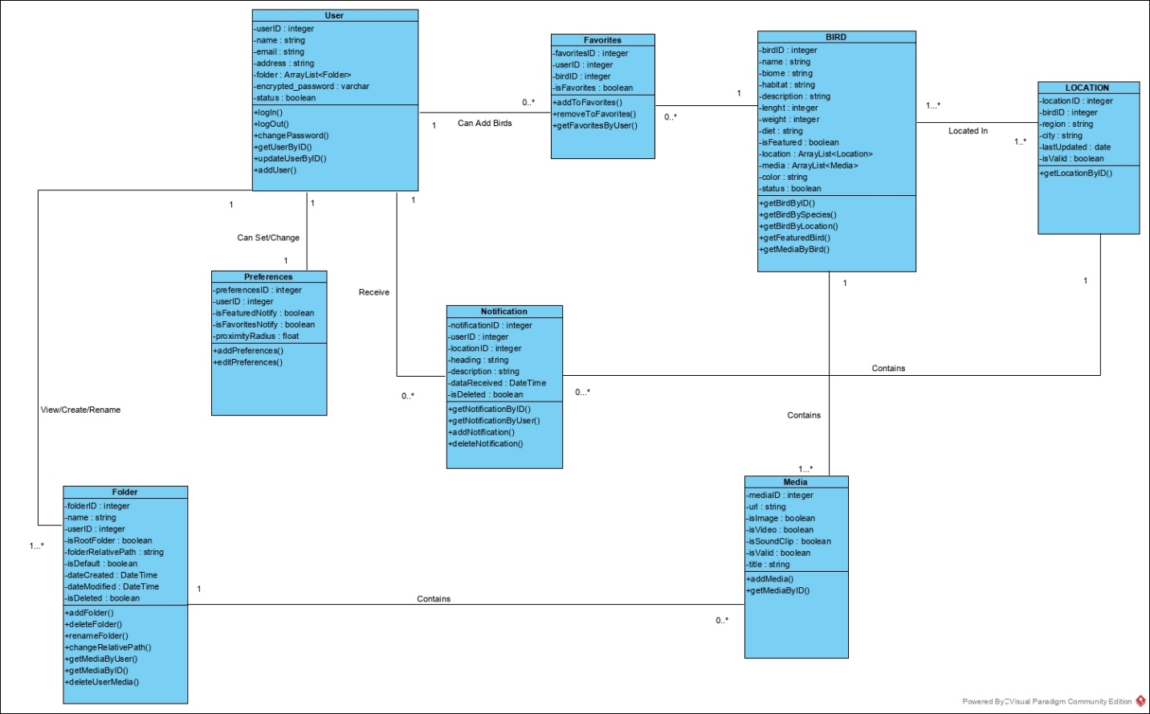

1. **ER Diagram**

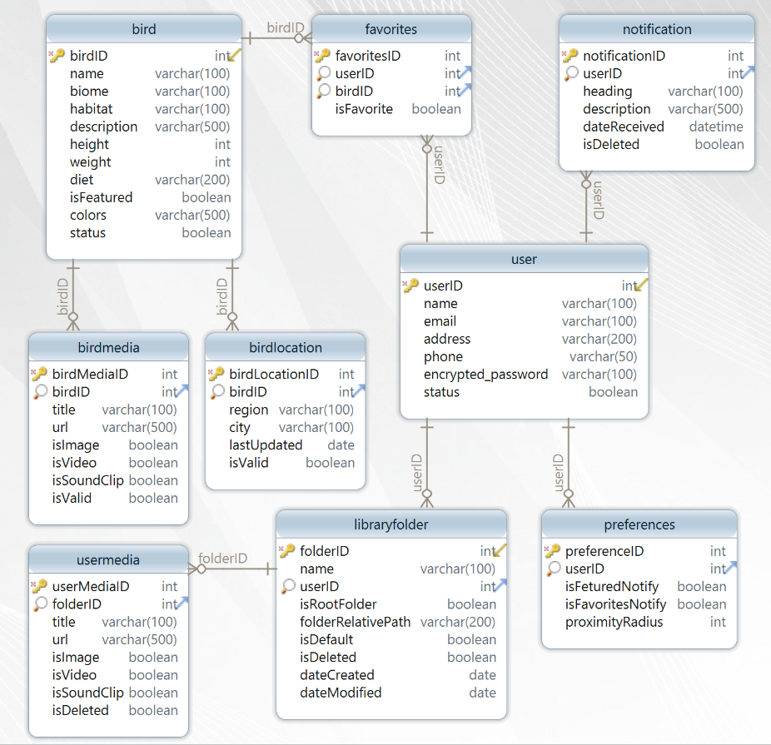

1. **Conceptual Data Model**

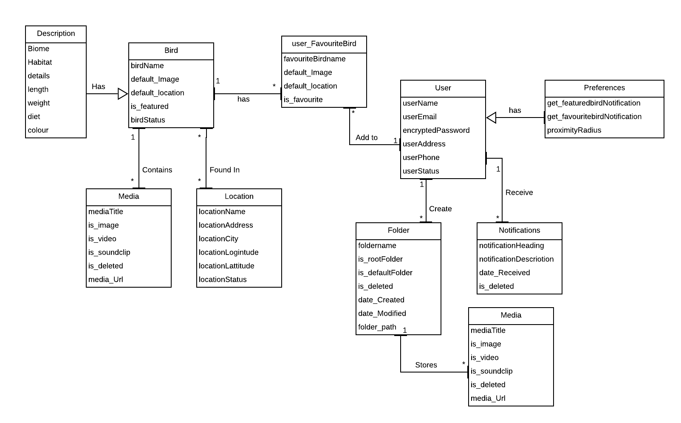

1. **Document Data Model**

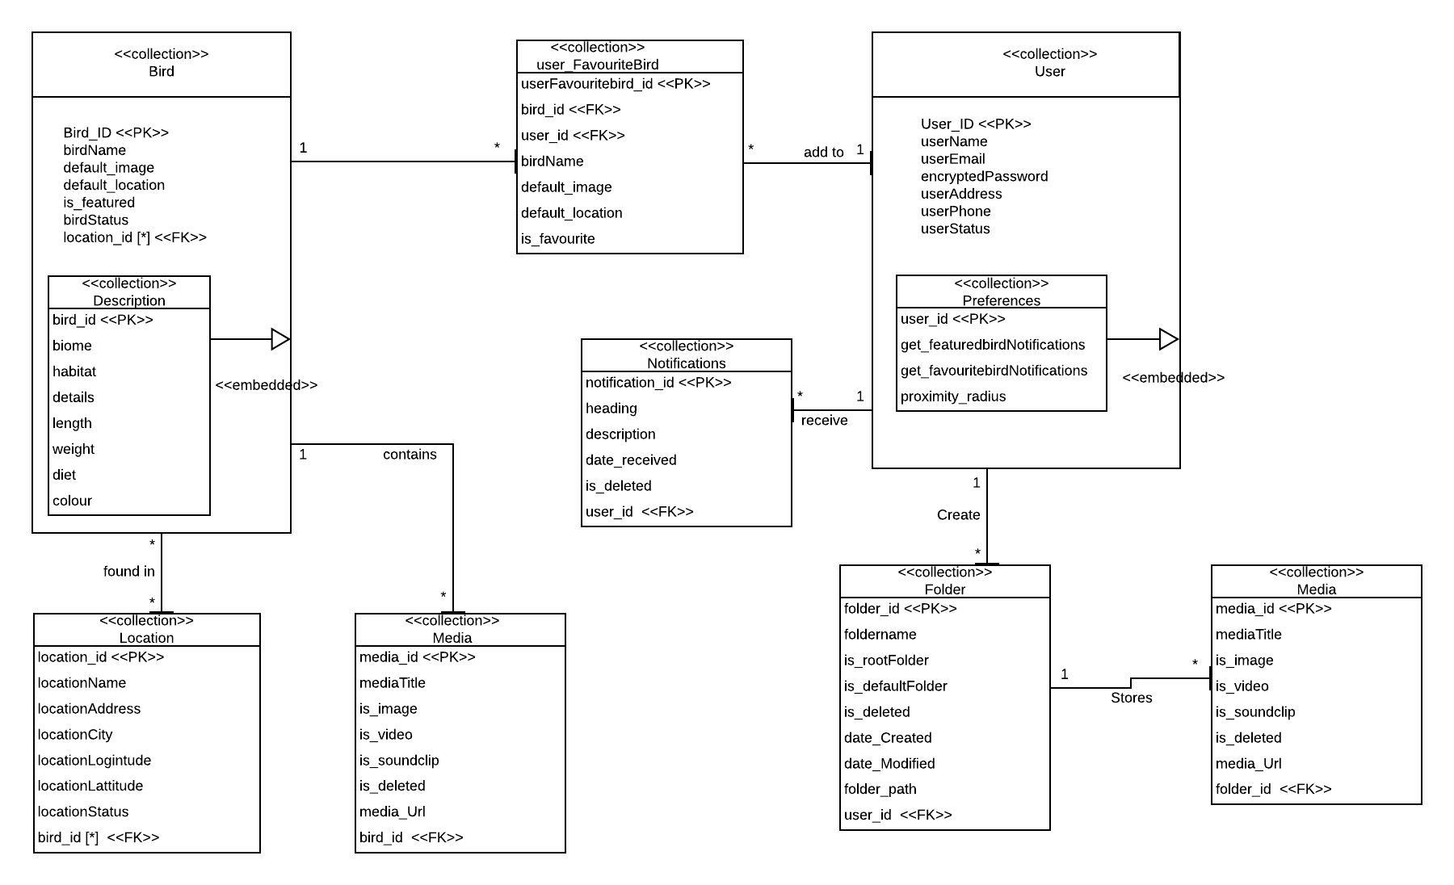

1. **Firebase Collection Database - Sample JSON**

"bird": {

        "bird_id": 1,

        "name": "Sparrow",

        "default_image": "sampleURL",

        "default_location": "Montreal",

        "is_featured": true,

        "status": true,

        "description": {

            "biome": "sample",

            "habitat": "sample",

            "details": "sample",

            "height": "sample",

            "weight": "sample",

            "diet": "sample",

            "colors": ["yellow", "red", "blue", "violet"]

        },

        "media": {

            "media_id": 1,

            "title": "sample",

            "is_image": true,

            "is_video": true,

            "is_sound_clip": true,

            "is_deleted": true,

            "url": "sample URL"}

    },

    "user": {

        "user_id": 1,

        "name": "sample",

        "email": "sample",

        "encrypted_password": "sample",

        "addres": "sample",

        "phone": "sample",

        "status": true,

        "preferences": {

            "get_featured_notifications": true,

            "get_favorites_notifications": true,

            "proximity_radius": "sample"

        },

        "notifications": {

            "notification_id": 1,

            "heading": "sample",

            "description": "sample",

            "date_received": "sample",

            "is_deleted": "sample"

        },

        "folder": {

            "folder_id": 1,

            "name": "sample",

            "is_root_folder": true,

            "is_default": true,

            "is_deleted": false,

            "folder_path": "sample",

            "date_created": "sample",

            "date_modified": "sample",

            "media": {

                "media_id": 1,

                "title": "sample",

                "is_image": true,

                "is_video": true,

                "is_sound_clip": true,

                "is_deleted": true,

                "url": "sample URL"}

        }

    },

    "user_favorite_birds": {

        "user_favorite_birds": 1,

        "user_id": 1,

        "bird_id": 1,

        "bird_name": "sample",

        "default_image": "sample URL",

        "default_location": "sample",

        "is_favorite": true

    },

    "location": {

        "location_id": 1,

        "region": "sample",

        "city": "sample",

        "latitude": "sample",

        "longitude": "sample"

    },

    "bird_location": {

        "bird_location_id": 1,

        "bird_id": 1,

        "location_id": 1,

        "bird_name": "sample",

        "location_name": "sample",

        "bird_image": "sample URL",

        "is_valid": true}

}

1. **Screens**

